|  |
| --- |
| **Interloper PI Detector** |
| IoT Application Project Proposal |
| An IoT based security application for detecting motion within a room, controlled by automated telegram bot. If motion is detected a buzzer would be triggered and a photo and video recording will be sent to the bot and emailed to the admin.  Fyaz Qadir Ahmed Ikram | K00237093 | Technological University of Shannon: Midlands & Midwest | Internet Systems Development | Year 4 | Technology Futures and Connected Living |
|  |

Table of Contents

Application Name and Description 2

Background Summary 2

System Architecture 4

References 4

# Application Name and Description

Application Name: Interloper PI Detector

Application Category: Home and Automation Monitoring

Application Description: Instant data feed on your mobile or email if a motion is detected in your house while you’re away.

# Background Summary

IoT applications run on Internet of Things devices and can be tailored to practically any sector or vertical, including healthcare, industrial automation, smart homes and buildings, automotive, and wearable technology. The scope of this project is to develop a home intrusion detection system for homeowners to prevent house burglary, around the Limerick area. According to PhoneWatch a burglary takes place in Ireland every 48 minutes. In the Limerick division there were a total of 158 burglaries in the year 2020.



Figure 1 Annual Crime Figures 2020

Due to these reasons the Author has decided to create an IoT application to reduce house burglaries in Limerick. This application will capture any motion detected using 2 PIR sensors in your house when you are away and alert you by email, mobile application and also via a custom-built telegram bot, attaching a photo and video capture. When a motion is triggered, the lights would be turned on to capture a clearer view of photos and videos and a buzzer ringer to signal that there has been an intrusion, in addition to a call being made to the guards, if the program is not stopped via the push button within 10 seconds. A custom-made website also shows a history of when the motion was detected, and allows the exporting of the data, to an excel spreadsheet, to aggregate and detect patterns within the data. All data is stored using Firebase Realtime Database and Storage. The application is planned to be operated via remote measures by using a telegram bot that allows users to start and stop the program when leaving the house. In comparison to other burglar systems this system would cost approximately $100 to build, which is way cheaper and more affordable for homeowners, compared to other systems which cost around $170 - $250. The application would be initially used in the Authors house to test how the application works and functions. This IoT application can replicate itself to work in other environments too in the future, such as in hospitals, airports etc.

There are many IoT applications that are already built around the area of home security and monitoring such as Motion Sensor by Code Cartel LLC, that records video automatically when it detects movement. Most home security monitoring apps have basic features such as record pictures/videos when a motion detected. What makes the Authors application unique is that when a motion is detected, the light turns on so it can capture a clearer video and photo capture of when the intruder was at the house, but also get immediate notifications via email and the telegram bot of both photo/video captures, when a motion was detected when you were away from home. What also makes this application unique is that all the commands to start, stop, and capture photos can all be done remotely using a telegram bot, which paves the way to use this application in one app instead of downloading a separate app that can control its functions.

According to Statista the number of IoT connected devices for security and fire alarms in 2021 was 338.7 million is expected to grow to 552.2 million by 2024 and then by 2030 to 1047 million. This shows that there is a huge scope of IoT devices in the security and fire alarms sector. This was also one huge factor why the Author had decided to develop an application around this market within the Internet of Things.

Figure Number of Internet of Things (IoT) connected devices worldwide from 2019 to 2030, by use case – Security and Fire Alarms (in millions)

Also, in addition, according to the IEEE Xplore “Internet of Things is composed of things that have unique identities and are connected to each other over internet. It is simply connecting and monitoring various devices and sensors through Internet. This paved the way for home automation and monitoring which makes human life more comfortable and secured.” This shows that the demand for IoT applications is increasing and becoming more popular among the commonfolk.

# System Architecture

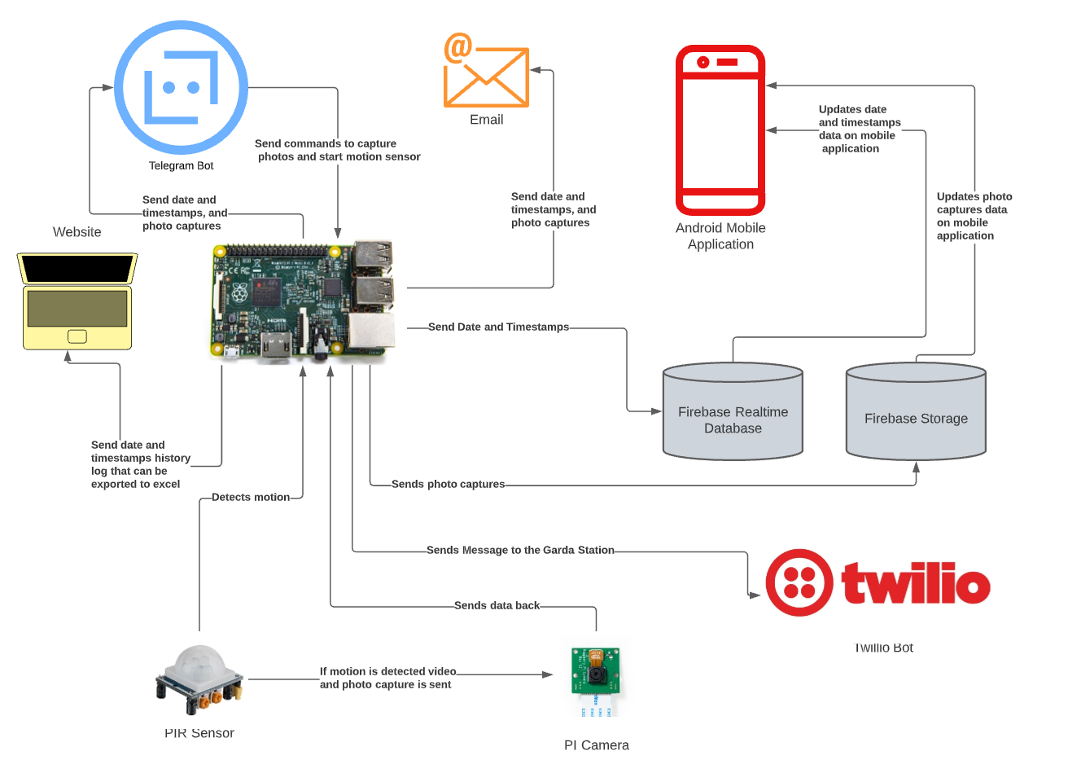

Figure 3 System Architecture Diagram

# References

**Background Research Material**

1. Statista. 2022. IoT connected devices by use case 2030 | Statista. [online] Available at: <https://www.statista.com/statistics/1194701/iot-connected-devices-use-case/> [Accessed 26 February 2022].
2. App Store. 2022. ‎Motion Sensor. [online] Available at: <https://apps.apple.com/us/app/motion-sensor/id1288112430> [Accessed 2 March 2022].
3. Findstack. 2022. 21+ Internet of Things Statistics, Facts & Trends for 2022. [online] Available at: <https://findstack.com/internet-of-things-statistics/> [Accessed 26 February 2022].
4. Watters, A., 2022. 30 Internet of Things Stats & Facts for 2022. [online] Default. Available at: <https://connect.comptia.org/blog/internet-of-things-stats-facts> [Accessed 26 February 2022].
5. Phonewatch.ie. 2022. CSO Burglary Map - PhoneWatch Alarm Systems. [online] Available at: <https://www.phonewatch.ie/security-guides-advice/cso-burglary-map/> [Accessed 7 March 2022].

**Technical Research:**

1. Telepot.readthedocs.io. 2022. Introduction — telepot 12.7 documentation. [online] Available at: <https://telepot.readthedocs.io/en/latest/> [Accessed 2 March 2022].
2. Iotdesignpro.com. 2022. How to Send SMTP Email using Raspberry Pi. [online] Available at: <https://iotdesignpro.com/projects/sending-smtp-email-using-raspberry-pi> [Accessed 2 March 2022].
3. Youtube.com. 2022. [online] Available at: <https://www.youtube.com/watch?v=2G1d3q8MlsI> [Accessed 2 March 2022].
4. Youtube.com. 2022. [online] Available at: <https://www.youtube.com/watch?v=By-pDkZ1Zws> [Accessed 2 March 2022].
5. Firebase. 2022. Installation & Setup in JavaScript | Firebase Documentation. [online] Available at: <https://firebase.google.com/docs/database/web/start> [Accessed 2 March 2022].
6. Android Developers. 2022. Documentation | Android Developers. [online] Available at: <https://developer.android.com/docs> [Accessed 2 March 2022].